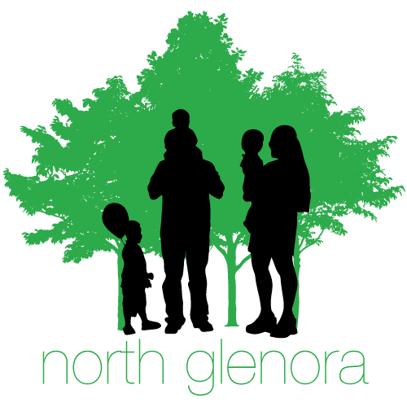
SUPERTOTS SOCCER REGISTRATION

Name of Player:__________________________________
Name of Parent:__________________________________
DOB:_________ F/M:________
Phone #:__________________
E-Mail:__________________________________________
Community League #:______________________________
Emergency Contact:________________________________
Emergency Contact #:_______________________________
Medical Conditions:________________________________
Are you willing to volunteer as a coach or assist? Yes No

Parent Signature:___________________________________
All fees must be paid either in person via cash or cheque payable to North Glenora Community League or using our Event Brite site http://ngclsoccer.eventbrite.ca. Cash/Cheque payment can be made at the North Glenora Community Hall (13535 109A Ave) March 4 2017 between 10am-2PM.

